Course Name | ITD 2343 – Object Oriented Programming with C#
Instructor | Mark L. Pranger
Student Name | Eric Christensen
Due date | Oct 16, 2025
Grade | <grade earned here>
Grading Comments | <instructor comments here>

Week 6 – Programming Lab

Screen Shots needed for Submission:
- Make a screen shot for each of the following points in the creation process
  - The form after you have completed all the visual changes specified in the UI design. many of the changes will not show in a screen shot but the color change will
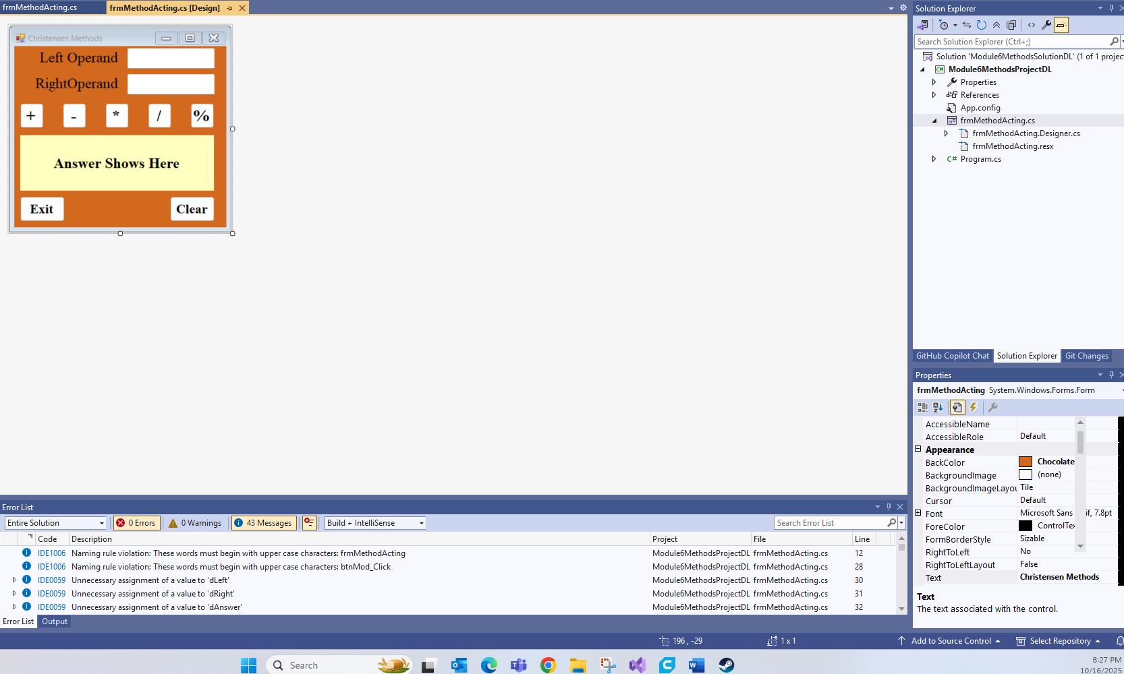

- Show the code for the method you create in as few screen shots as possible
  - Highlight the method code in the screen shot(s)
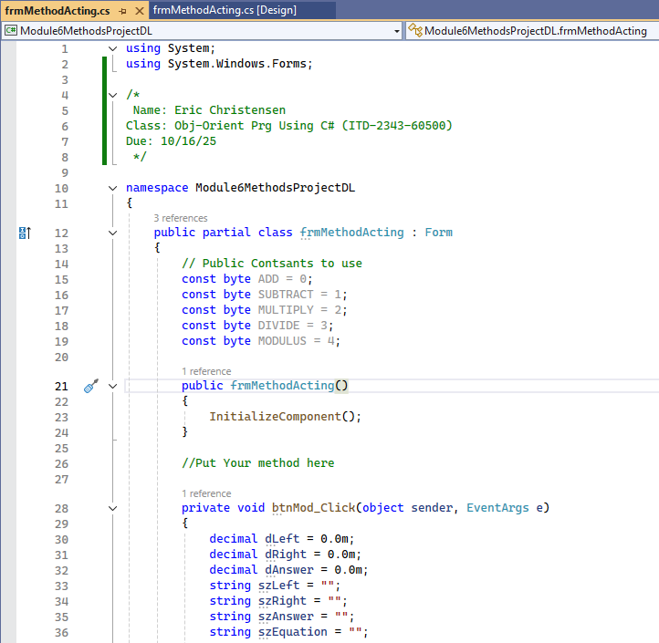
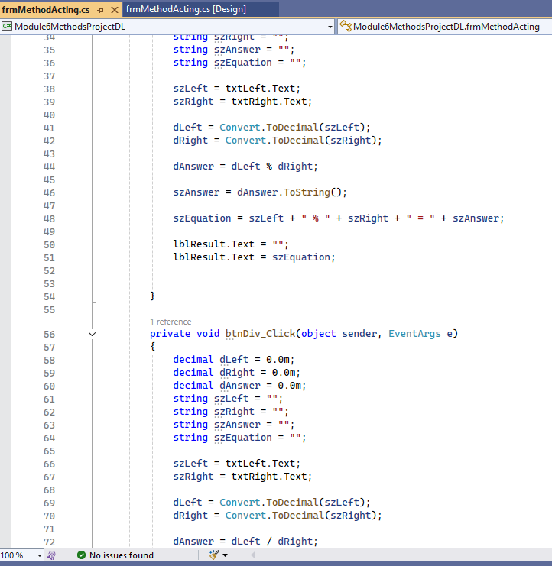
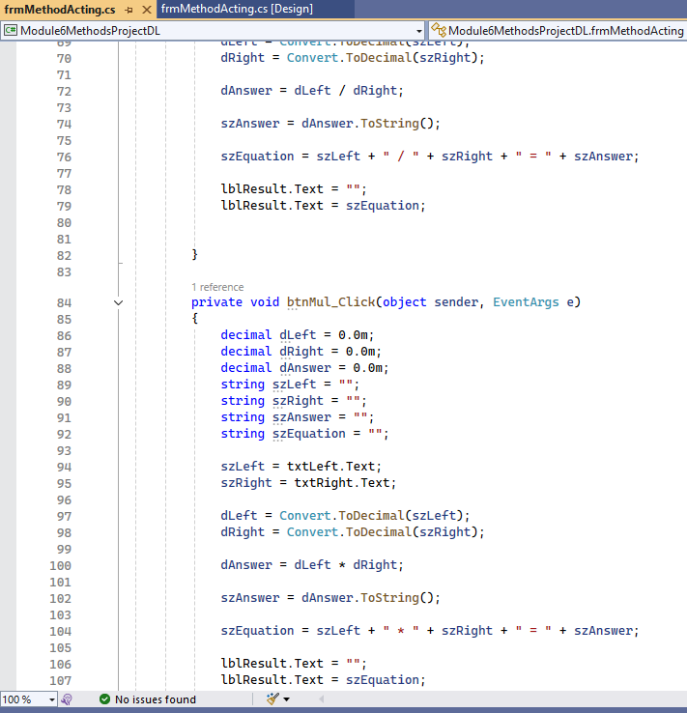
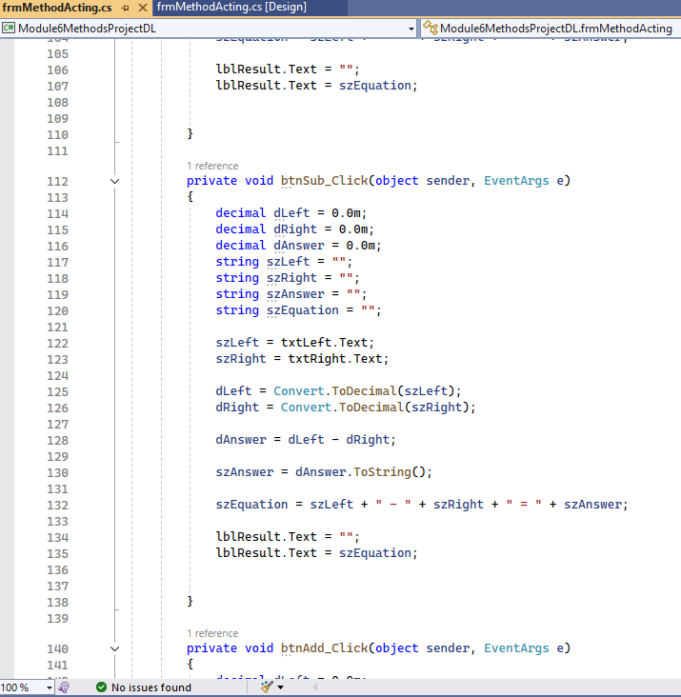
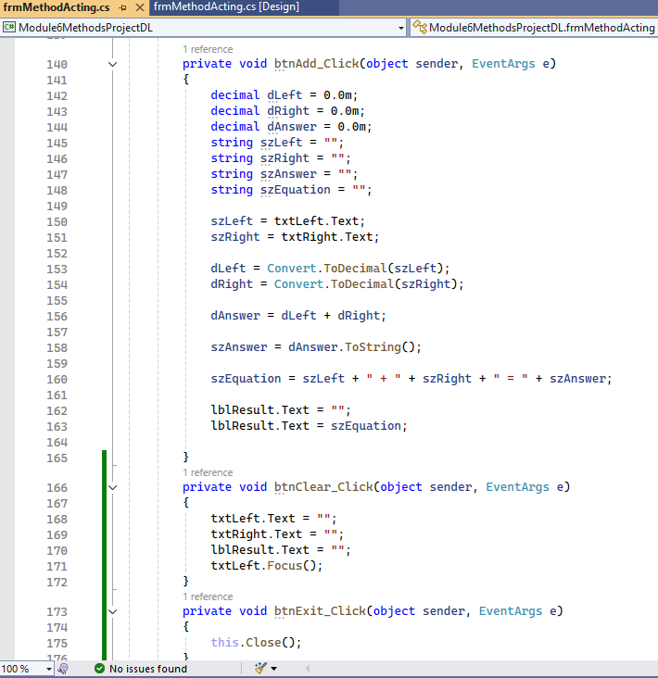
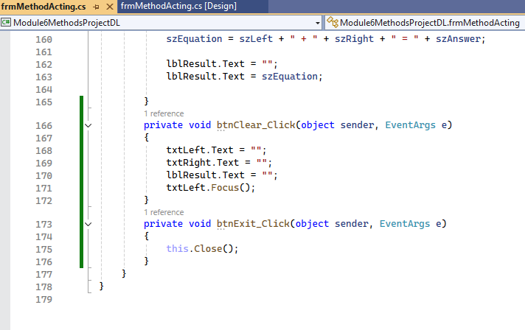

- Run the application in debug mode, screen shot the whole screen showing the form starting up
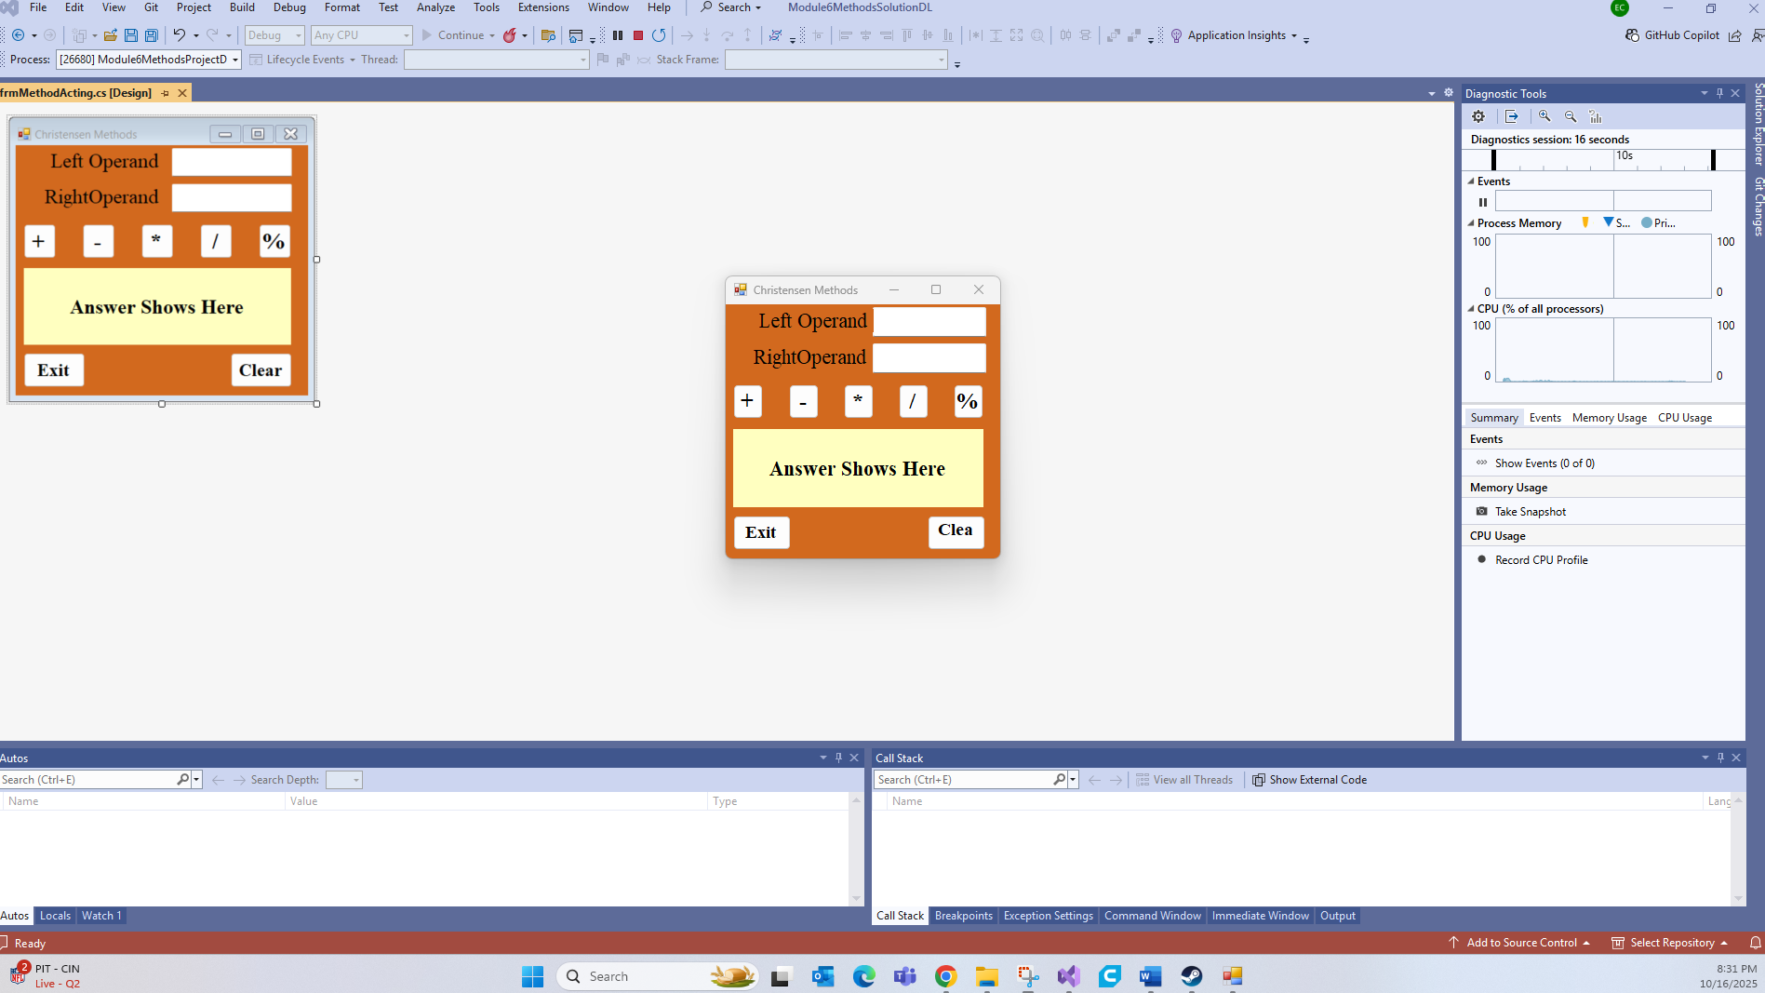

- For the operations screen shots, show one screen shot depicting each of the following scenarios
  - Use 73 for the left operand value and 37 for the right operand value for the following testing screen shots
  - Screen Shot the results of the + button being clicked
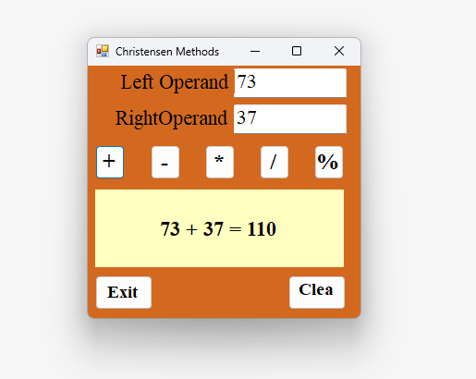
  - Screen Shot the results of the * button being clicked
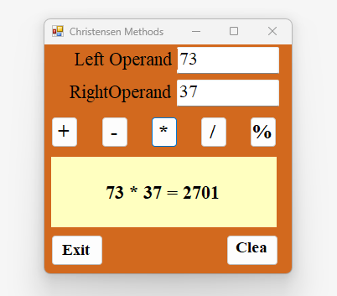

  - Screen Shot the results of the - button being clicked
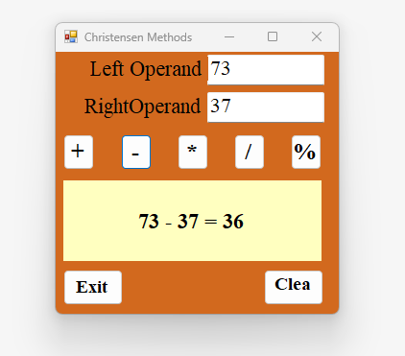

  - Screen Shot the results of the % button being clicked
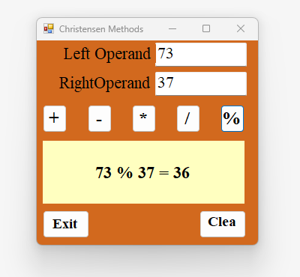

  - Screen Shot the results of the / button being clicked
